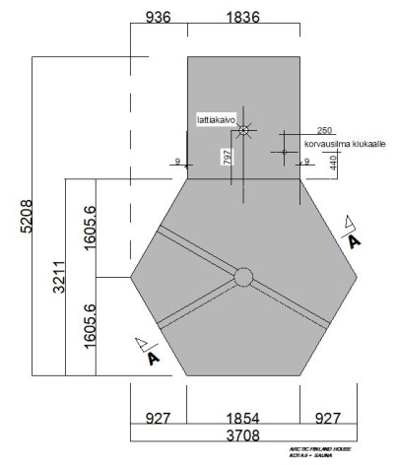

Edge-reinforced concrete slab
- At a depth of about 300 mm, remove the surface layer of the yard, lawn, soil, etc. from a sufficiently wide area. To the excavated area, add a layer of gravel (grain size 0-16mm) about 150mm thick. Compact the gravel layer to make a level surface.
- For the edge-reinforced foundation slab, build a formwork, e.g. from boards or plywood, with the dimensions shown in the diagram below. The height of the formwork is 250-300 mm. Check the formwork dimensions carefully!
- Install the grill air ducts according to the drawing. Place a culvert pipe (ø 315/275 mm SN4) or similar in the centre, including the base. Connect at least 3 universal ø 110 mm pipes to the culvert pipe installed in the centre. Use a keyhole saw to cut openings for connecting the pipes.
- Embed drainage pipes outside the slab foundation to go around the building. Connect a pipe to the drainage pipe using a T connection to drain water to the sewer or to the terrain. Add gravel to the centre of the foundation around the pipes. Over the levelled gravel, place a 50mm Styrofoam board according to the drawing.
- Use ready-mixed concrete for casting or make the concrete yourself. First, fill in the recesses (= slab edge reinforcements) on the edges of the area with concrete and then pour the entire slab up to the top of the mould. Place a steel mesh about 30 mm below the future floor. Carefully level the concrete slab and make sure the formwork is durable!
- Allow the concrete slab to dry well. Carefully remove the formwork without breaking the slab corners. Place grilles on the ends of the air ducts. Air conditioning valve US-SV 100–125. Install the bottom frame supplied with the product carefully over bitumen felt strip at the edge of the concrete slab.
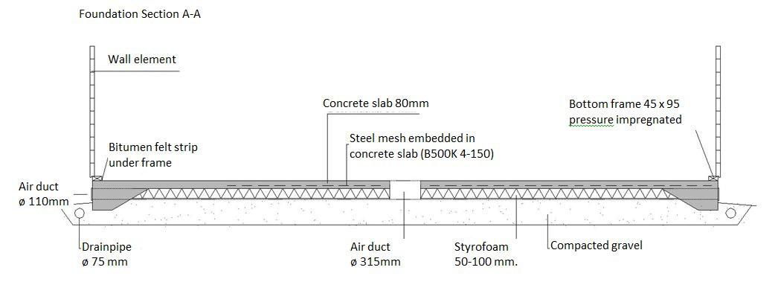
Note! When laying the foundations, the soil on which to build must be taken into account. The foundations are laid according to the soil and, if necessary, following separate foundation and structural plans for which the customer is responsible. This foundation guide is for reference only.

